Kitchen Newsletter
Target Date: 11-16-17
Title: Holiday Cookies – Fast and Festive
Constant Contact Name:

November 16, 2016 – Holiday Cookies

Subject Line:
Holiday Cookies – Fast and Festive!

Teaser Line:
Fast and festive holiday baking!

Facebook and/or Twitter Words:

It’s time to plan your holiday baking! This year our plan includes a clever strategy for making lots of festive cookies fast! In our latest newsletter, we’re featuring a trio of slice-and-bake cookies along with tons of tips and techniques needed for baking success. Get our recipes and all the details and inspiration here: <link>

In This Issue:

Slice-and-Bake Techniques
RECIPE: Mocha Shortbread Squares
Baking Tools
Tips for Slice-and-Bake Cookie Success:
RECIPE: Red and White Checkerboard Cookies
RECIPE: Glazed Lemon Wafers

INTRO

“Holiday Cookies – Fast & Festive!”

IMG 6050 or IMG 6061

INTRO TEXT

It’s time to plan your holiday baking! This year our plan includes a clever strategy for making lots of festive cookies fast! IN THIS ISSUE, we’re featuring a trio of slice-and-bake cookies along with all the tips and techniques needed for baking success. You’ll be adding these cookies to your list of “must-make-holiday-favorites.”

Thumbnails
“”

MAIN BODY:

REPEAT THANKGIVING CHECKLIST AND LINK --

Secrets for Fast & Festive Cookies!
Time is precious these days! So much to accomplish! We’re sure you have a list of “must-make-favorites” for the cookie plate, we do, too! But, every year we like to try a few new cookies and add to our favorites list. This year, we’re experimenting with slice-and-bake cookies in new and creative ways – best part? They are super-fast to make and certainly festive!

Slice-and-Bake Cookies
Cookies fall into several general categories – drop, cut-out, bars, no-bake, molded, and so many more! The slice-and-bake cookie genre is typified by cookie dough that’s mixed and formed into rolls. Once well-chilled, individual cookies are sliced from the cookie dough log and baked.
Advantages of Slice-and-Bake Cookies:
- Lots of cookies can be formed fast and baked quickly.
- The dough may be mixed and log rolls formed ahead of time.
- The log rolls may be formed in many shapes for different cookie designs and sizes.
- Bake cookies at the last minute for fresh, warm cookies.
- Most slice-and-bake cookies do not spread overly when baked which means more cookies may be baked at a time.
- Bake only what’s desired at any given time – no leftovers, unless you want them, of course.
- Adapt to a variety of flavors and decoration options.

Basic Slice-and-Bake Techniques: (see the TOP TIPS below, too!)
Slice-and-bake cookie dough is most often a shortbread-style dough – just butter, sugar, flour, salt, flavorings, and maybe an egg or egg yolk. The ingredients are so few, so choose quality ingredients. While there are many variations to slice-and-bake cookies, each follows a similar technique:

Step 1 – Mix the softened butter and sugars until just mixed. No need to beat until fluffy – just mix until combined.

Step 2 – Add any eggs, if part of the recipe, and any flavorings. Mix until combined evenly.

Step 3 – Whisk the dry ingredients together – flour, salt, other powders. Add to the butter and sugar mixture.

Step 4 – Form logs with the cookie dough. Divide the dough in half for easier handling. Chill or freeze.

Step 5 – Slice the dough logs, bake, cool, and ENJOY!

Mocha Shortbread Squares
Not only are these cookies easy to make, they are swoon worthy! With classic shortbread cookie roots, these cookies are imbued with special powers due to a deliberate double-down on chocolate and a healthy dose of espresso. One secret to these cookies is the coarse salt or crumbled flaked salt. It doesn’t quite dissolve into the dough, so that when eaten, random salty bursts occur making these cookies extra wonderful. We’ve dressed them for holiday success with a drizzle of melted white chocolate. No matter the season, it’s worth keeping a log of this dough in the freezer for chocolate-craving emergencies. (This cookie was inspired by Dorie Greenspan’s World Peace Cookies, which are also beyond scrumptious!)

Easy Decorating of Slice-and-Bake Cookies
Add a little flourish to slice-and-bake cookies with a simple drizzle of melted chocolate. Use a fork or whisk dipped in melted chocolate (white, milk, or dark) and wave over the cooled cookies.

Slice-and-Bake Improvisation:
Turn these cookies, or any slice and bake cookie into a sandwich cookie by layering two together and filling with icing. These Mocha Shortbread Squares sandwich nicely with a peppermint-flavored icing in the middle. Peppermint mocha – a classic holiday flavor all in one bite!
Holiday Baking Essentials:

 |  | 
KITCHENAID  STAND MIXER | CUISINART  HAND MIXER | NIELSEN MASSEY  VANILLA EXTRACT
You’ll be amazed at how much easier it is to bake and cook with this able machine at your side. Don’t wait any longer. | For smaller tasks, this hand mixer fits the job! Mix up small batches in a jiffy. Clean-up is easy. Stores compactly. | Use only pure vanilla extract when baking. And, this vanilla is the best of the best.
 | 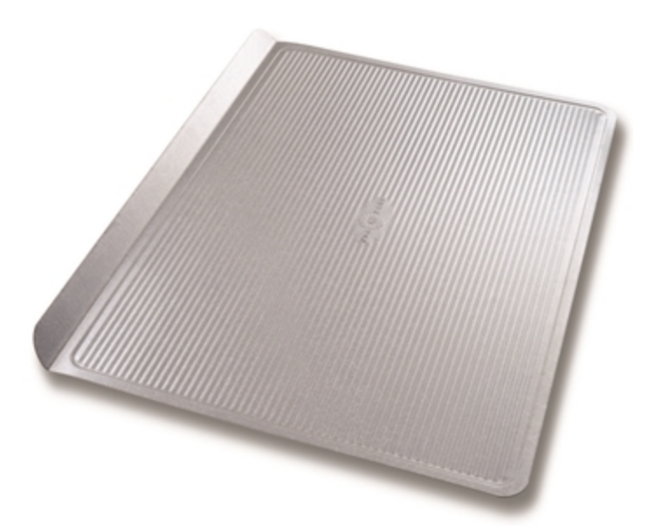 | 
PARCHMENT  PAPER | USA PANS  COOKIE SHEETS | OXO GOOD GRIPS  COOKIE SPATULA
Line countertops and baking sheets with parchment paper to create a nonstick surface and for easy clean-up. | A remarkable nonstick surface on a sturdy, well-constructed cookie sheet. Distributes heat evenly for precise baking. | The perfect spatula for transferring cookies from the baking sheet. Thin, flexible -- -cookies stay intact.
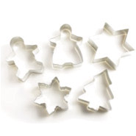
COOKIE CUTTERS
Unleash your creativity this season! We have a large variety of cookie cutters to fit any occasion and to inspire some baking fun.

Tips for Slice-and-Bake Cookie Success:

When mixing:

- Use butter that’s softened to room temperature. Leave cold butter on the kitchen counter for 30 minutes and it will become soft. If in a hurry, cut the butter into chunks and spread on a plate to hasten the warming.

- Unlike many cookies and cakes where the first step of beating of the sugar and butter is key for achieving the right texture, slice-and-bake cookies do not require extra beating at this first stage. Just mix the butter and sugar until combined, then proceed with the remaining ingredients.

- Gather the mixed dough, divide in half for easier handling and storage. Use wax paper or parchment paper to help in the rolling and log-forming process.

- Wrap the formed dough rolls well in plastic wrap so that when chilling the dough does not pick up any off odor from the refrigerator or freezer.

- Chill the dough logs for at least 2 hours or up to 3 days. Or, freeze the dough logs for longer storage. Allow frozen logs to set at room temperature for about 15-20 before slicing.

When slicing:
- Use a larger knife with a sharp, thin blade. Though a paring knife (3- to 4-inch blade) might fit and cut well, a larger chef’s knife (6- to 8-inch blade) works best; it’s easier to slice firmly and vertically.

- As you slice, keep the knife clean by frequent wiping with a cloth, or by lightly dusting with a little flour.

- Rotate the log as you slice so that it maintains its round or square shape; repeated slicing downward can distort the dough log.

- Cut even slices – about 1/4-inch thick. Even slices will result in the cookies baking evenly.

- Keep extra dough rolls chilled for neater slicing; slice only one log at a time. Re-chill the dough whenever it gets too soft.

When baking:
- Because slice-and-bake cookies are made from a dense dough, they do not spread as much as other cookies when baked. Leave about 1-inch of space between the cookies.

- Know your oven. If the back heats more intensely than the front, rotate the baking sheets halfway through the baking process.

- Use the first batch to gauge the proper baking time for your oven; then, time remaining batches accordingly.

- Avoid opening the oven door when baking cookies. The temperature drops precipitously whenever the door is opened.

- The cookies are done when a light fingertip touch rebounds a little bit, or just when the bottoms of the cookies just barely begin to brown. Use the recipe instructions for a good guideline.

- Cool baking sheets completely between the batches of cookies. A warm cookie sheet will “melt” the cookie resulting in misshapen cookies.

- Cool baked cookies on the baking sheet set on a cooling rack for 2-4 minutes to allow the cookies to set. However, don’t leave them on the baking sheet longer than this. Remove them from the baking sheet and place on a cooling rack to completely cool.

Red & White Checkerboard Cookies
The first reaction these cookies receive is, “how did you do that???” You could spin a good story about painstakingly assembling each little cookie square by hand, or simply smugly say, “enjoy!” Thanks to super-fast, highly efficient, slice-and-bake techniques, you can make dozens of these eye-catching checkerboard cookies and add them to the holiday cookie plate, the office party table, or place under the tree for Santa’s drive-by event.

Easy Decorating of Slice-and-Bake Cookies
These checkerboard cookies are striking all on their own, but we dressed them up just a little bit more with an edge decoration. We dipped just the edge in a little vanilla frosting, then pressed the edge into white nonpareils. This technique would work nicely on any slice-and-bake cookie.

Slice-and-Bake Improvisation:
Turn these cookies into “lumberjack flannel” cookies by using red dough and chocolate dough. The result is a great looking buffalo check now in cookie form. Just add 1/4 cup of cocoa powder to half the dough along with an extra egg yolk.

Glazed Lemon Wafers
These cookies feature bursts of lemon flavors in every bite. Two kinds of lemon – fresh lemon zest and pure lemon extract – reside in the cookie dough, and fresh lemon juice flavors the thin glaze on top. The result is something wonderfully crunchy and piquantly delicious. The dough – a simple variation on classic shortbread, assembles quickly, rolls neatly, and slices well.

Easy Decorating of Slice-and-Bake Cookies
While rolling the dough logs, add a decorating step in the final stage. Sprinkle coarse sanding sugar, food glitter, or any confectionary decoration on the dough-rolling surface and roll the log so that the decorations adhere evenly across the roll. We used white sanding sugar on our lemon wafers, but, go crazy, and use a bright red or green.

The tops of slice-and-bake cookies are an invitation for decorations. Sprinkle sanding sugars, food glitter, or nonpareils on top of the sliced, ready-to-bake cookies. Press in slightly. A light egg wash (an egg and a teaspoon of water) on top of the cookies will bake into a golden color on top and will help some more elaborate decorations stick. (First, test the decorations on the egg wash to check for any bleeding of colors.)

Slice-and-Bake Improvisation:
Turn these cookies into a sandwich cookie by using the citrusy icing as a filling instead of a glaze. Totally wonderful!

Use all white sugar instead of half brown and half white if a lighter color of cookie is desired.

Substitute lime or orange zest and juice for the lemon flavors throughout the recipe. A totally different experience.

Add 1/4 cup poppy seeds to the dough (prior to adding the flour) for a delicious Lemon-Poppyseed Cookie.

